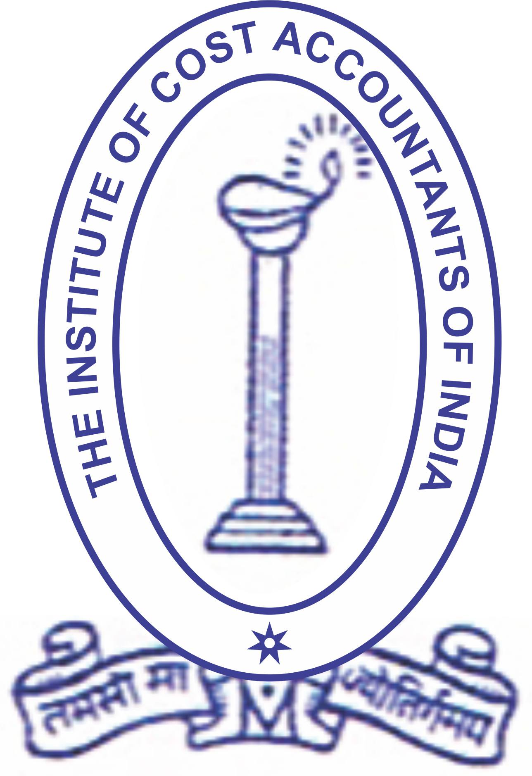

THE INSTITUTE OF COST ACCOUNTANTS OF INDIA
(Set up under an Act of Parliament)
VAPI-DAMAN-SILVASSA CHAPTER OF COST ACCOUNTANTS OF WIRC

Full day Seminar on

Export-Import benefits & Obligations

On

Thursday, 12th February,2015 – Kamat Resort(Lotus resort) , Silvassa

Program Schedule
Time | Particulars | Speaker
9-45 am to 10-15 am | Registration & Breakfast
10-15 am to 10.30 am | Welcome Address | CMA B F Modi
10.30am to 11.30 | Overview of EXIM policy and Procedures | CMA Ashok Nawal
11-30am to 11.45 | TEA BREAK
11.45 to 1.30 pm | Export benefits under various schemes like Deemed export, focus market | CMA Ashok Nawal
1-30 pm to 2-30 pm | LUNCH
2-30 pm to 3-45 pm | Drawback, AI Rates  Documentations & Procedures for claiming benefits | CMA Ashok Nawal
3.45 pm to 4.00 pm | TEA BREAK
4.00 to 4.30 | Question – Answer session
4.30pm | Vote of Thanks | CMA R M Kandoi
Participation fees : Rs. 1500 per participant payable in the name of “Vapi-Daman-Silvassa Chapter of Cost Accountants”. The fees include study material, Tea, breakfast and lunch. Fee for CMA’s : Rs. 1000.

Contact persons :CMA B F Modi (9879612689, bfmodi@rediffmail.com), CMA R M Kandoi (9825111796, rmkandoi@rediffmail.com), Vapi office : 9727084636
CEP Credit for CMA’s :4 hours.

Vapi-Daman-Silvassa chapter of Cost Accountants of WIRC of ICAI, 20, 2nd floor, Girnar Khushboo Plaza, Near Vishal Mega Mart, GIDC, Vapi-396195 bfmodi@gmail.com / vapi@icmai.in : www.cma-vapi.com

Need for the seminar ……..

The Government has given thrust to Exports by various benefits from time to time. For a normal business entity it is difficult to know and claim various benefits with frequent changes and also complication in procedures.

It is necessary that the Exporters and importers are aware of what benefits are available and how to claim them. Also their obligations to be fulfilled.

This seminar is aimed to cover All the documentation and procedures under the Foreign Trade policy. The topics to be covered will be –

Advance authorisation, EPCG Authorisation (Licence), Duty free imports, Duty Drawback, AI rate and Brand rate fixation, Credit schemes like Focus Market, Focus product, Served from India scheme, Vishesh Krishi and Gram udyog scheme, Status holder incentives. Deemed export benefits and Market development benefits.

Participants are requested to send their querries in advance to bfmodi@gmail.com or rmkandoi@rediffmail.com. All attempts will be made to incorporate the response in presentations by the speakers or in Question-answer session.

About the Speaker ….

Mr. Ashok Nawal :

Mr. Ashok Nawal is a Fellow member of the Institute of Cost accountants of India and Chairman of Western India Regional council. After industry experience of 17 years in various companies started practice as Cost Accountant since 1997. Mr. Nawal is a Managing Director of Bizsolindia Services Pvt. Ltd - a leading management consultancy firm on Indirect Taxation, EXIM and FEMA. A member of various task forces on EOU, SEZ etc. with the Ministry of Commerce & Industry. Past chairman of Western India Regional council of the Institute of Cost Accountants, Advisor, confederation of Export Units, New Delhi and member on various advisories of the Government. Contributed to various publictions of ICAI.

Faculty for no. of seminars on indirect taxation, SEZ, EOU etc. and a guest faculty at Management institutions. An author of no. of articles in business and professional journals and is an excellent orator.

THE INSTITUTE OF COST ACCOUNTANTS OF INDIA
(Set up under an Act of Parliament)
VAPI-DAMAN-SILVASSA CHAPTER OF COST ACCOUNTANTS OF WIRC

Full day Seminar on

Export-Import benefits & Obligations
On
Thursday, 12th February,2015 – Kamat Resort(Lotus resort) , Silvassa

Delegate Registration form
We are pleased to nominate following participants for the above workshop:

Sr.No. | Name | Designation | Contact Tel.No. | Email id

Participation fees : Rs. 1500 per participant payable in the name of “Vapi-Daman-Silvassa chapter of Cost Accountants”.Fees for CMA – Rs. 1000. Fees include Lunch, relevant study material, circulars etc. Fees once paid are non-refundable. Change in participants is allowed. Cost Accountants will get CEP Credit of 4 hours. Fees can be directly deposited in our Bank account : Bank of Baroda, Vapi Town Branch, A/c. no.02370100018539, RTGS/NEFT IFSC Code BARB0VAPIXX.

Details of Sponsoring organisation :

Name & address of the company: ____________________________________

Contact Person : Name :_____________________Contact Tel.No.________________

Signature of company official
Contact persons : CMA B F Modi-9879612689, CMA R M Kandoi : 9825111796. bfmodi@rediffmail.com, vapi@icmai.in

